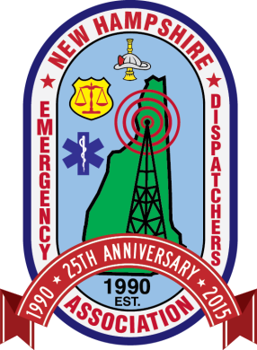
New Hampshire Emergency Dispatchers Association
PO Box 664 Berlin, NH 03570
www.nheda.org

Scholarship Application

Scholarships are awarded on a case by case basis, as determined by the NHEDA Governing Body.
Prerequisites: Active Member
Approval from the chief or head of your agency

Full Name: _____________________________________________________
Department/Agency: _____________________________________________
Address: _____________________________________________________________________________
Position/Title: __________________________________________________
Phone Number: ______________________________ Fax Number: ____________________________
E-mail: __________________________________________________________________
Training Opportunity Requested: _________________________________________________________
With this completed application, please submit an essay as to why you want to attend this training/educational experience.
If awarded a scholarship, by signing below, you would be allowing NHEDA to use your image as well as your agency in our promotional materials and online (i.e. press release).

________________________________ ________________________
Applicant Signature Date
As the Department head or chief of this agency (or designee), I understand that the applicant is applying for a scholarship with NHEDA for the purpose of attending a training/educational opportunity. I fully support the applicant attending as well as applying for this scholarship.

_________________________________ _________________________
Department Head/Chief or designee Date
Please email completed application to secretary@nheda.org or mail completed application to address above.

